Are the typical IND enabling studies which meet US GLP/GMP standards required for FIH imaging studies?
There is a framework for this approach in the US using an exploratory IND (eIND) route, where you do not require non-cGMP precursor for manufacturing. However, the FDA eIND guidance for industry is silent on the requirements for a GLP tox study. We have opened an eIND and will request a Type C meeting with FDA where we will provide justification as to why we do not require GLP tox study to support a Phase 0 FIH imaging study and ask the agency if they agree. At the same time, we will get feedback on the Master Clinical Protocol.
More broadly, our strategy for FIH imaging studies is listed below with the appropriate competent authority legislation.
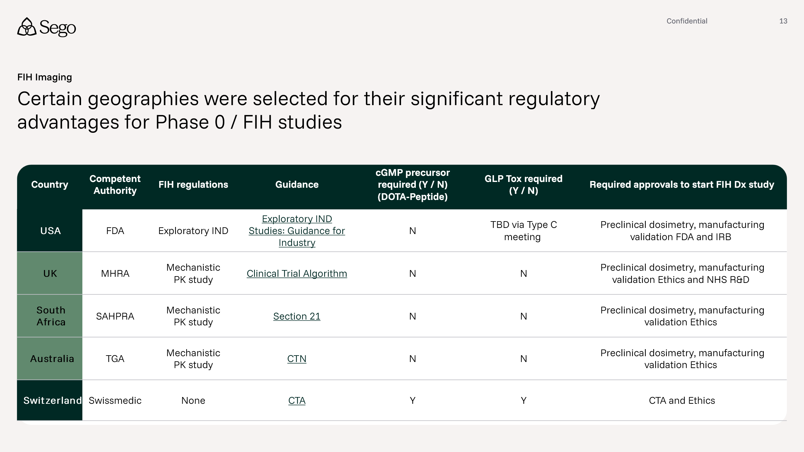

Where will we conduct our clinical work?
The initial sites are depicted below.
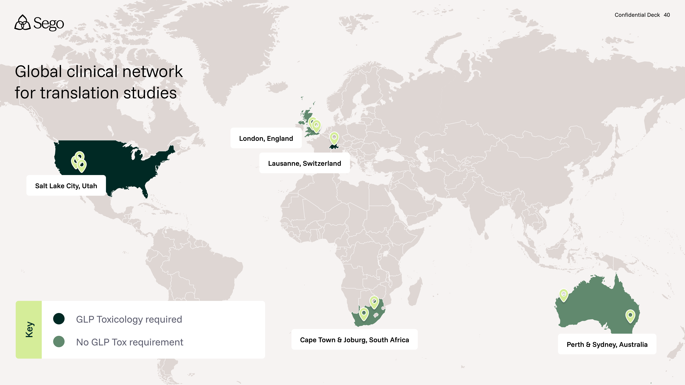

What parameters did we use for site selection?
The initial selection criteria are:
- The PI has previous experience in conducting Phase 0/FIH and Phase 1 diagnostic and therapeutic imaging studies
  - The Sego founders have run studies directly with the PI previously and have experience of high performance
- Established local manufacturing / radiopharmacy of PET and SPECT diagnostic doses and potential to manufacture therapeutic RLT doses
- Clinical Trials Unit familiar with RLT studies
- The site routinely provides performs clinical PET, SPECT and RLT therapy dosing
We are currently in discussion with the sites to establish a Master Clinical Trial Agreement and will conduct a formal feasibility exercise prior to signing the agreement.

Why aren't we using Germany as a clinical site?
We are not leveraging Germany because the regulatory pathways available for early, exploratory clinical work do not allow for standardized, highly rigorous, prospectively defined protocols that generate reproducible comparative data.
While we have prior experience working with KOLs under §13(2b) AMG and AMRadV, this framework is designed for physician-led individual treatment use — similar to named patient or compassionate use — rather than structured clinical investigation. These evaluations do not require a formal protocol, predefined inclusion/exclusion criteria, prospectively defined endpoints, or controlled study design. As a result, they are not suitable for our objective: a methodical, PK- and imaging dosimetry-driven comparison of multiple compounds against the same target to enable data-driven lead selection.
A formal prospective Ph 1 imaging study in Germany is technically possible; however, it would fall under BfArM oversight. BfArM is widely regarded as slow in approving radiopharma studies, introducing meaningful timeline risk to the development plan.
What specific capabilities are you building out in CMC Stage 1? What are we building out in CMC Stage 2?
Stage 1 will be built to supply early clinical studies (up to Ph 2) with Stage 2 bringing significantly expanded capabilities and the ability to supply Ph 3 and commercially. See slide for details.
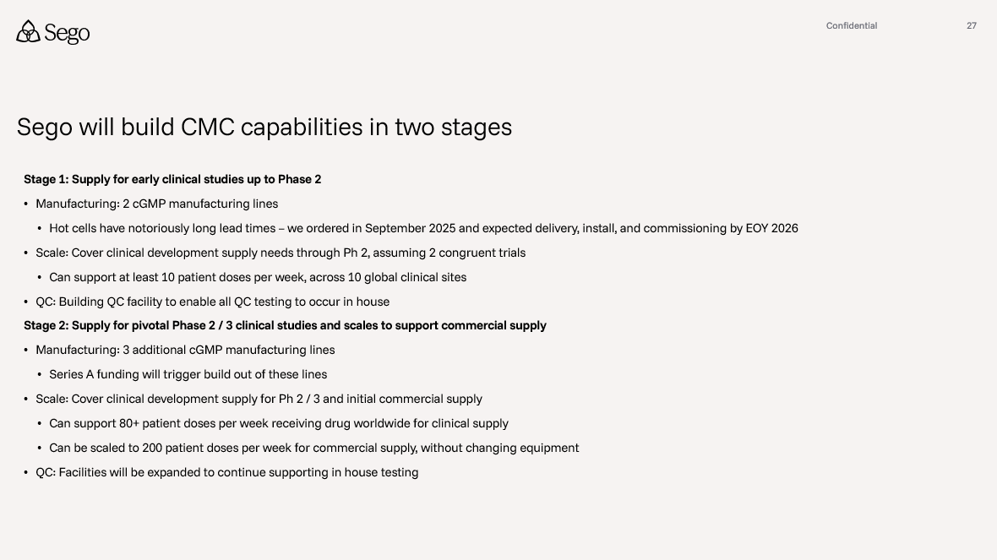
Are we planning to have FIH data from two molecules by the Series A?
Yes, we are planning and budgeting to have data from two FIH studies for the Series A in mid-2028. The current budget and plan have one study completed mid-2028, and a second study with interim data mid-2028 and completing end of 2028.

How did we evaluate CROs for externalized research?
We systematically evaluated multiple CROs against a Sego-defined RLT development workflow (as depicted below), assessing their capabilities across each stage from hit identification through cold and hot optimization, IND-enabling, and early clinical readiness. For each CRO, we scored technical capabilities, supporting infrastructure, and execution experience, alongside qualitative factors such as culture fit, risk, and inflection points for program advancement. This structured comparison enabled a transparent, side-by-side assessment of strengths, gaps, and cost models to inform CRO selection and partnering strategy.
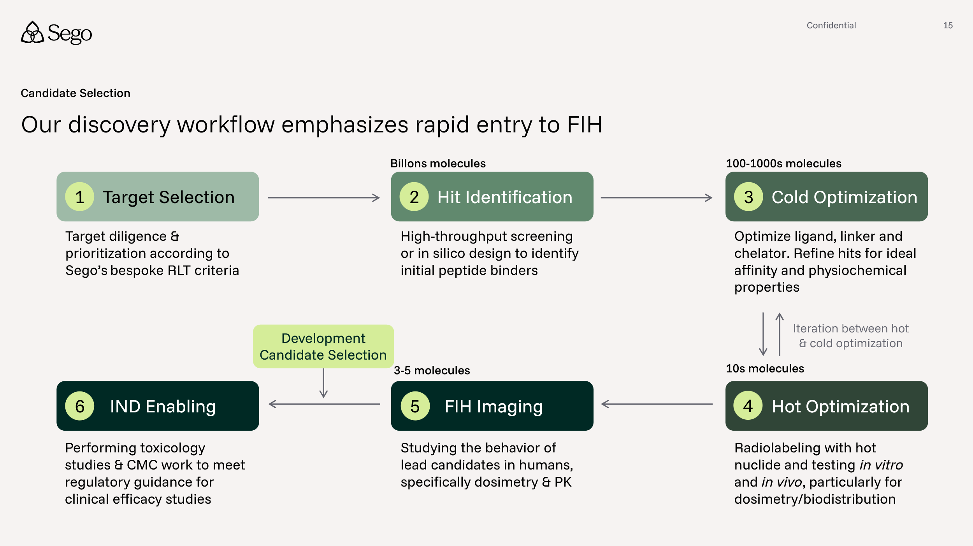

What CROs will we leverage for our externalized research (e.g. CRO1, CRO2)?
We have selected Wuxi as our first CRO for externalized research, with evaluation continuing to identify “CRO2” and additional CROs for different types of externalized work.
Wuxi was selected for multiple reasons, including: (1) their extensive capabilities across our discovery workflow, from peptide screening, through to in vivo radiation capabilities (2) they offer highly competitive pricing (3) members of our team have deep experience working with teams at Wuxi and high confidence in the quality of work produced.
Looking beyond Wuxi, we are evaluating an additional 4-5 CROs. Of these, 2 CROs may have end to end capabilities through partnerships with external organizations. 2-3 providers would only cover steps 2 and 3 of our workflow above - screening & cold optimization. Another provider would only be potentially utilized for hot work.
How will we make decisions about on- and off- ramping programs from different CROs?
Programs are advanced through our discovery workflow using defined stage gates with explicit on- and off-ramps at each stage transition, allowing us to evaluate progress and, if appropriate, transition work between CROs at predetermined inflection points. These transitions correspond to the stages in our workflow (Target Selection → Hit Identification → Cold Optimization → Hot Optimization → FIH Imaging → IND Enabling), with each gate tied to a specific technical data package and decision criteria. For example, hit quality and binder diversity following screening or SAR progression and PK characteristics after cold optimization.

These gates provide both objective go/no-go decisions for program advancement and clearly defined operational points where a program can move to the CRO best suited for the next type of work. For instance, a program may begin with a screening-focused CRO during Hit Identification, transition to a medicinal chemistry-focused CRO during Cold Optimization, and move to a specialized radiochemistry and in vivo radiation CRO for Hot Optimization and dosimetry studies. However, our intention is to use these off ramps sparingly.

By structuring CRO transitions around these defined stage gates, we ensure that any on- or off-ramping occurs only at natural program milestones with complete data packages, minimizing disruption while maintaining flexibility to optimize quality, speed, and risk management throughout the discovery process.

